To all MPs in England
22 August 2020

Greencore – Closure and Interventions

Dear Colleague,

As you will be aware, action is being taken in your local area by the Government, in close consultation with local leaders, Directors of Public Health and Greencore management, as a result of the increased prevalence of coronavirus in the company’s workforce.

Greencore has chosen to voluntarily close its Northampton factory sites, and many of its staff will be required to self-isolate, along with their households, given the risk that they have been exposed to coronavirus. I know these measures are difficult for those of your constituents affected, due to the impact they have on their way of life and ability to socialise with friends and loved ones, so I want to thank you for the constructive approach you have taken to these challenging yet necessary measures to keep the virus under control in your area.

Following a deep-clean of the Greencore factory sites, some staff will be allowed back into work, provided they had not been in the factory (or in close contact with anyone else who had) since 7 August. The company has already been improving hygiene practices and will continue to do so while the sites are closed to ensure a safe return to work for employees.
These enforced self-isolation measures are being taken to minimise the risk that those who have been working in the Greencore factories, which has seen the largest workplace outbreak in the country to date, transmit the virus to the wider community.

Coronavirus guidance

The actions that have been taken are informed by the Contain Framework (published on 17 July, and available at https://www.gov.uk/government/publications/containing-and-managing-local-coronavirus-covid-19-outbreaks/covid-19-contain-framework-a-guide-for-local-decision-makers), which sets out how national and local partners will work with the public at a local level to prevent, contain and manage outbreaks.

I’m aware that you and your constituents may have questions relating to the actions being taken by the government, and to the levels of coronavirus within your local area. I hope you will find the following resources helpful:

- Guidance on local interventions is published on gov.uk at
https://www.gov.uk/government/collections/local-restrictions-areas-with-an-outbreak-of-coronavirus-covid-19
and it will be updated shortly to provide more information for your constituents;
- Detailed data and analysis on the epidemiology of COVID-19 can be found in the Public Health England surveillance report at https://www.gov.uk/government/publications/national-covid-19-surveillance-reports. This now includes additional maps for each area showing the prevalence of the virus by lower super output area, which I hope you will find useful. I have also attached the full Watchlist table which contains information about the prevalence of the virus by Lower Tier Local Authority;
- Further data, including coronavirus testing and cases can be found at https://coronavirus.data.gov.uk/

I know how difficult these decisions will be for those who are those affected, and we take this action with a heavy heart. However, I would like to emphasise the Government’s determination to do whatever is necessary to keep people safe.

If you have any questions for what these measures mean for your constituents, please do not hesitate to get in touch.
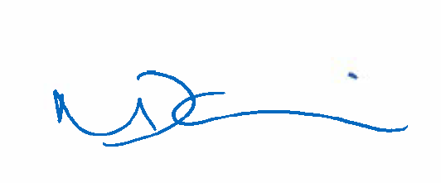

NADINE DORRIES

